The Document Object Model (DOM) is a cross-platform and language-independent application programming interface that treats an HTML, XHTML, or XML document as a tree structure wherein each node is an object representing a part of the document. The DOM model represents a document with a logical tree. Each branch of the tree ends in a node, and each node contains objects. DOM methods allow programmatic access to the tree; with them one can change the structure, style or content of a document.

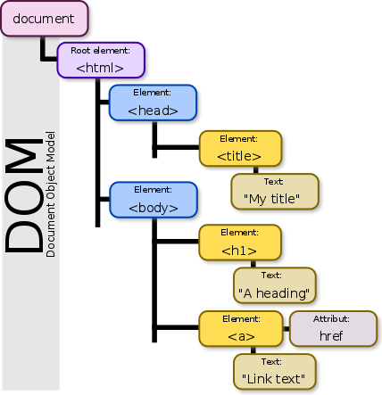

**“HTML DOM is an API Interface provided by browser vendors.”**

Example:

* HTML DOM for Chrome is provided by Google
* HTML DOM for Firefox is provided by Mozilla
* HTML DOM for Internet Explorer is provided by Microsoft
* HTML DOM for Safari is provided by Apple

Any websites should write compatible code with the browser specific HTML DOM Interface API.

All DOM have the CRUD [Create, Read, Update, and Delete] operations interface API.

**Web browsers [All browsers have their own DOM and follows W3 standards]**

To render a document such as a HTML page, most web browsers use an internal model similar to the DOM. The nodes of every document are organized in a tree structure, called the DOM tree, with the topmost node named as "Document object". When an HTML page is rendered in browsers, the browser downloads the HTML into local memory and automatically parses it to display the page on screen.

**DOM is created for Every Page:**

* HOME
* About Us
* Contact Us

**Reason for StaleElementException**

Page gets loaded a DOM is created and after refreshing the page a new DOM is created. [Meaning existing DOM is cleared and a new DOM is created]

**JavaScript**

When a web page is loaded, the browser creates a Document Object Model of the page, which is an object oriented representation of an HTML document that acts as an interface between JavaScript and the document itself and allows the creation of dynamic web pages:

JavaScript can add, change, and remove all of the HTML elements and attributes in the page.

JavaScript can change all of the CSS styles in the page.

JavaScript can react to all the existing events in the page.

JavaScript can create new events within the page.

Using JavaScript CRUD operations – the page elements behavior can be dynamically changed

**References:**

<https://www.w3.org/DOM/>

<https://www.xul.fr/en/dom/>

<https://www.w3schools.com/js/js_htmldom.asp>

Wikipedia & Google.com ☺